Account database is initially empty.
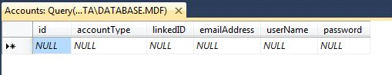
Here is the list of services available on the AccountService class. This file handles account creation and logging in.
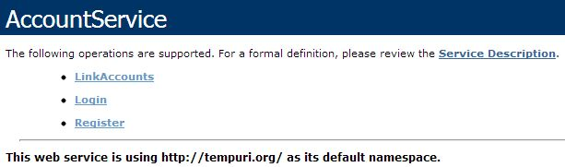
A parent account 'Bobby' is created.
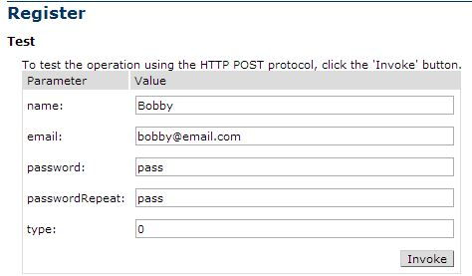
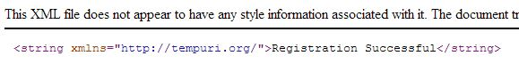

A student account 'Bobby junior' is also created. This will also add him to the Student database.
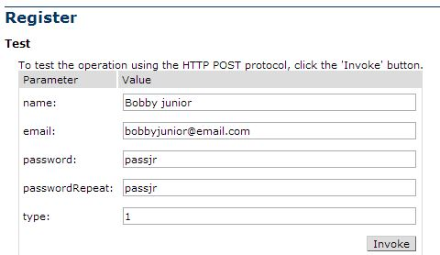
Now the two accounts are linked.
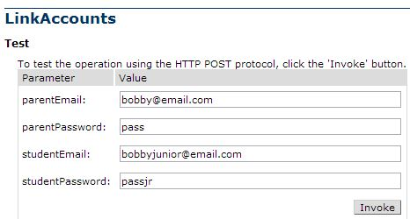
The results are shown in the Accounts database.
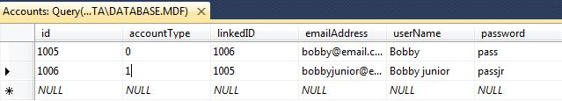

Now either account can log in. Note that all methods will return a non-string acknowledgment after a browser interface has been implemented.
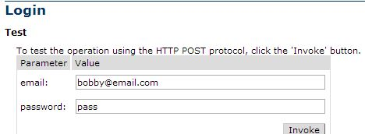
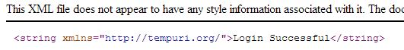
Here is the list of services available on the StudentDataService class. This file is mostly concerned with managing classes and other data relating to a student account.
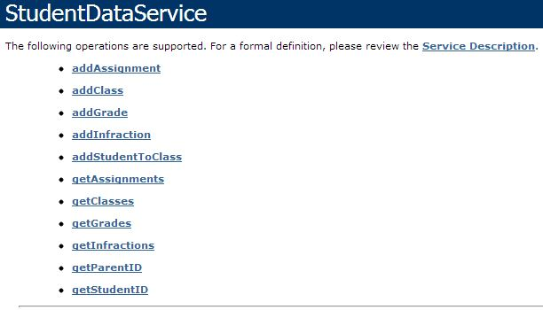
First, a class 'Algebra' is created. The teacher account was already created.
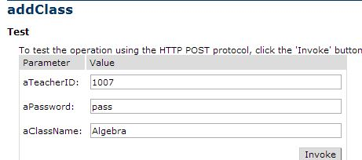
Then an assignment is added to the course.
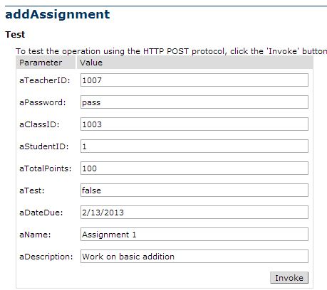
Next, a grade for Bobby Junior is added to the Grades database.
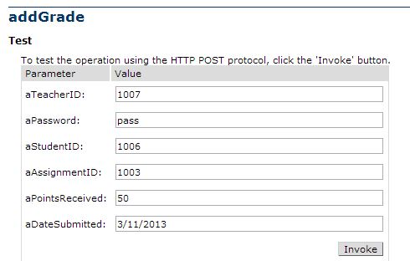

All of the information has now been added to the appropriate database.
